DATA ENCRYPTION STANDARD ALGORITHM: DES

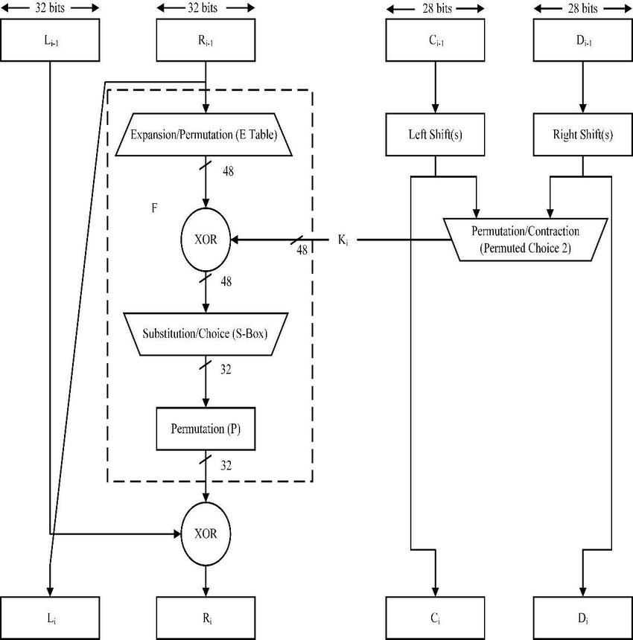

DES stands for Data Encryption Standard. There are certain machines that can be used to crack the DES algorithm. The DES algorithm uses a key of 56-bit size. Using this key, the DES takes a block of 64-bit plain text as input and generates a block of 64-bit cipher text.
The DES process has several steps involved in it, where each step is called a round. Depending upon the size of the key being used, the number of rounds varies. For example, a 128-bit key requires 10 rounds, a 192-bit key requires 12 rounds, and so on.
We live so much of our lives today on the internet. Whether it’s for storing our personal information, finding entertainment, making purchases, or doing our jobs, our society relies increasingly on an online presence.
This increased dependence on the internet means that information security is more important than ever. The stakes are too high now. Users need to know that their sensitive data is kept confidential, unmodified, and readily available to authorized readers.
Data encryption is just one weapon in the cybersecurity arsenal, but it’s one of the oldest and most used. And since no discussion about data encryption is complete without talking about DES, here we are!

Data Encryption Standard (DES)
DES stands for Data Encryption Standard. There are certain machines that can be used to crack the DES algorithm. The DES algorithm uses a key of 56-bit size. Using this key, the DES takes a block of 64-bit plain text as input and generates a block of 64-bit cipher text.
The DES process has several steps involved in it, where each step is called a round. Depending upon the size of the key being used, the number of rounds varies. For example, a 128-bit key requires 10 rounds, a 192-bit key requires 12 rounds, and so on.
Take a look at the video below which explains steps for encryption and decryption in detail, future of the Data Encryption Standard in cryptography and live example to further highlight the characteristics of DES encryption.

w Program

The DES (Data Encryption Standard) algorithm is a symmetric-key block cipher created in the early 1970s by an IBM team and adopted by the National Institute of Standards and Technology (NIST). The algorithm takes the plain text in 64-bit blocks and converts them into ciphertext using 48-bit keys.
Since it’s a symmetric-key algorithm, it employs the same key in both encrypting and decrypting the data. If it were an asymmetrical algorithm, it would use different keys for encryption and decryption.

History of DES Algorithm
DES is based on the Feistel block cipher, called LUCIFER, developed in 1971 by IBM cryptography researcher Horst Feistel. DES uses 16 rounds of the Feistel structure, using a different key for each round.
DES became the approved federal encryption standard in November 1976 and was subsequently reaffirmed as the standard in 1983, 1988, and 1999.
DES’s dominance came to an end in 2002, when the Advanced Encryption Standard (AES) replaced the DES encryption algorithm as the accepted standard, following a public competition to find a replacement. The NIST officially withdrew FIPS 46-3 (the 1999 reaffirmation) in May 2005, although Triple DES (3DES), remains approved for sensitive government information through 2030.

Initial Permutation (IP)
The plain text is divided into smaller chunks of 64-bit size. The IP is performed before the first round. This phase describes the implementation of the transposition process. For example, the 58th bit replaces the first bit, the 50th bit replaces the second bit, and so on. The resultant 64-bit text is split into two equal halves of 32-bit each called Left Plain Text (LPT) and Right Plain Text (RPT).

Step 1: Key Transformation
We already know that the DES process uses a 56-bit key, which is obtained by eliminating all the bits present in every 8th position in a 64-bit key. In this step, a 48-bit key is generated. The 56-bit key is split into two equal halves and depending upon the number of rounds the bits are shifted to the left in a circular fashion.
Due to this, all the bits in the key are rearranged again. We can observe that some of the bits get eliminated during the shifting process, producing a 48-bit key. This process is known as compression permutation.

Step 2: Expansion Permutation(I
Let's consider an RPT of the 32-bit size that is created in the IP stage. In this step, it is expanded from 32-bit to 48-bit. The RPT of 32-bit size is broken down into 8 chunks of 4 bits each and extra two bits are added to every chunk, later on, the bits are permutated among themselves leading to 48-bit data. An XOR function is applied in between the 48-bit key obtained from step 1 and the 48-bit expanded RPT.

DES Algorithm Steps
To put it in simple terms, DES takes 64-bit plain text and turns it into a 64-bit ciphertext. And since we’re talking about asymmetric algorithms, the same key is used when it’s time to decrypt the text.
The algorithm process breaks down into the following steps:
- The process begins with the 64-bit plain text block getting handed over to an initial permutation (IP) function.
- The initial permutation (IP) is then performed on the plain text.
- Next, the initial permutation (IP) creates two halves of the permuted block, referred to as Left Plain Text (LPT) and Right Plain Text (RPT).
- Each LPT and RPT goes through 16 rounds of the encryption process.
- Finally, the LPT and RPT are rejoined, and a Final Permutation (FP) is performed on the newly combined block.
- The result of this process produces the desired 64-bit ciphertext.
The encryption process step (step 4, above) is further broken down into five stages:
- Key transformation
- Expansion permutation
- S-Box permutation
- P-Box permutation
- XOR and swap
For decryption, we use the same algorithm, and we reverse the order of the 16 round keys.
Next, to better understand what is DES, let us learn the various modes of operation for DES

